FAGLL03H-G/L LINE ITEM BROWSER - FOR DISPLAY OF FUNCTIONAL AREA ADJUSTMENT POSTINGS



The purpose of this simulation is to show how to use T-Code FAGLL03H - G/L Line Item Browser report to check the postings made by Functional Area Adjustment process (ZFGL01 in ST and/or TX ledger(s) only). This is based on the specific features of such documents.

There is a separate simulation describing the general functionalities of T-Code FAGLL03H if you need further general information about FAGLL03H.

Click to continue.

Explanation | Screenshot
[1] fagll03h is now entered in the Transaction box. | 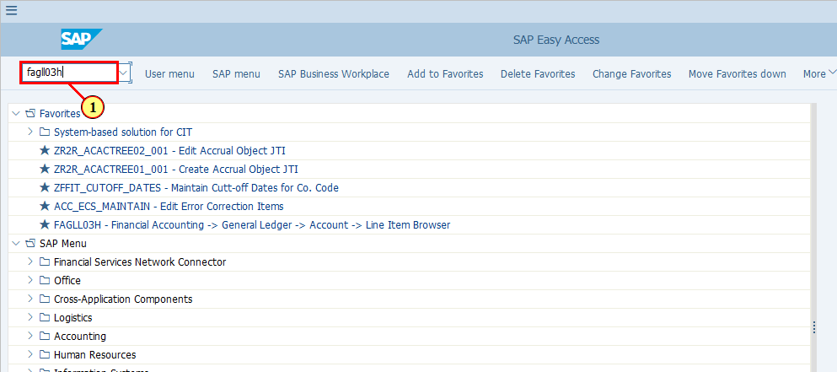
  In FAGLL03H - G/L Line Items Browser, we would like to see the postings made via Functional Area Adjustment ZFGL01.  There are many ways you can find such documents, for example:  - You can use Document Numbers from the ZFGL01 log as an additional selection criterion, if you have the log.  - You can put the G/L accounts used, together with the posting date range as selection criteria.  - If you know the original FI document numbers based on which the Functional Area Adjustments were posted, you can put those document numbers as Reference to search for line items posted with those documents as reference documents.  - You may also use Document Type as we know Functional Area Adjustments are posted with Document Type SA unless you specify using the original Document Type. However, you should note that there are also other transactions posting documents with Doc Type SA, such as AP/AR Regrouping for 3rd party vendors/customers.  If you do not have much details related to the above, you can simply use a G/L account range. As we know that all the Functional Area Adjustment postings are made using specially defined accounts, which are in the range of 891000-899999. In this simulation we will be using this G/L account range for demonstration.  Click to continue.  [2] The Company Code field is filled out. | 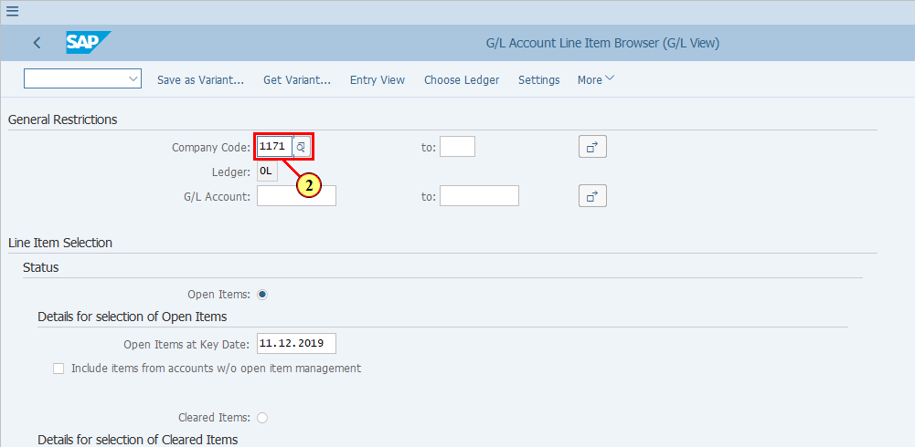
  Functional Area Adjustment postings are made to the required Statutory and/or Tax ledgers based on entity requirements. By default the FAGLL03H shows Ledger 0L. You will need to change this to either ST or TX in order to find the required Functional Area Adjustment documents.  [3] Click Choose Ledger .  You can also press Ctrl+F3. | 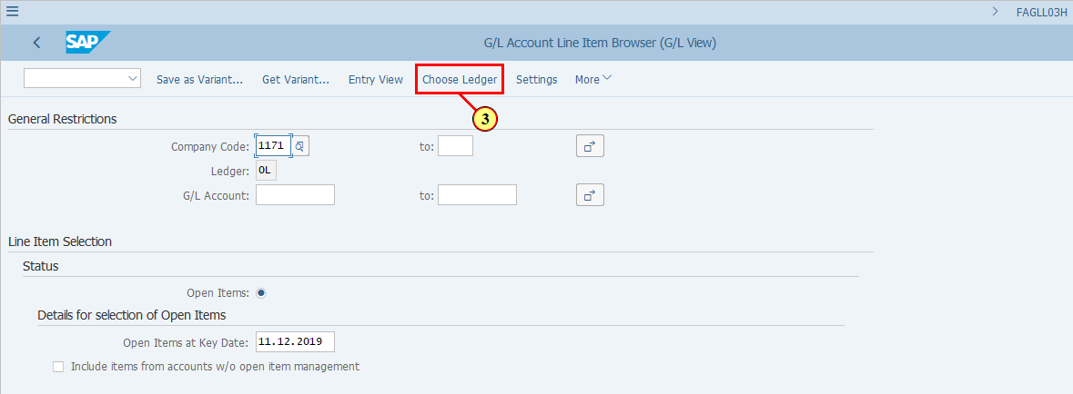
[4] The *Ledger field is filled out. | 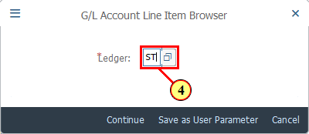
[5] Click Continue .  You can also press Enter. | 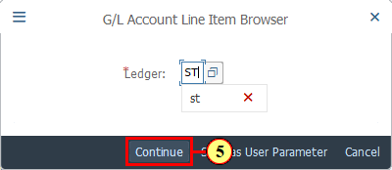
[6] The G/L Account field is filled out. | 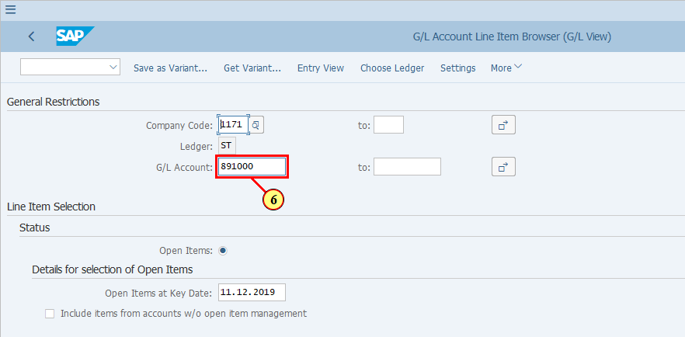
[7] The to field is filled with 899999 | 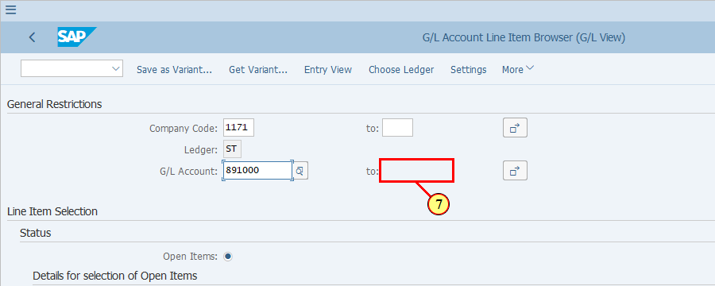
[8] Click All Items . | 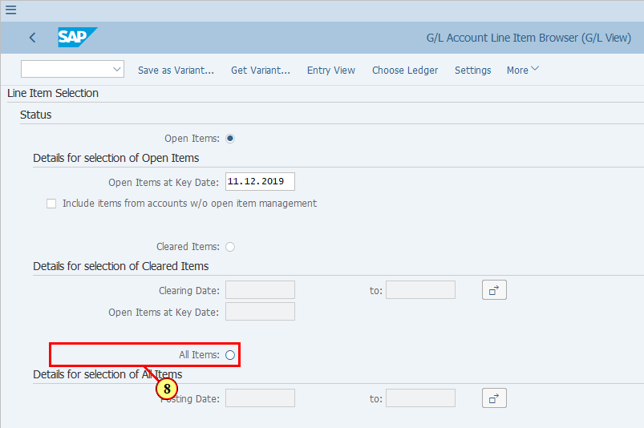
  The Posting Dates used in Functional Area Adjustment documents are not the last date of the period but the same dates as in the Posting Date field of the original documents where P&Ls were posted. Therefore we will put the date of current posting period here.  [9] The Posting Date field is filled out. | 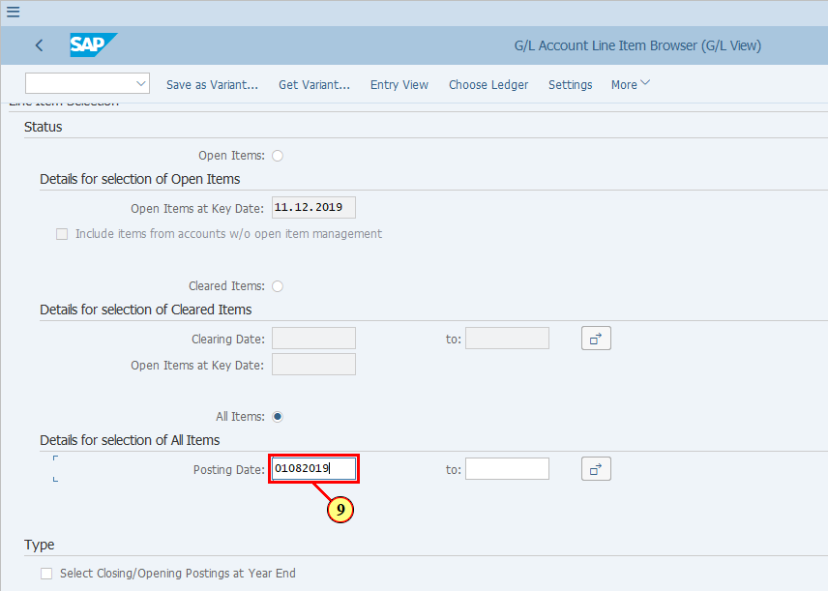
[10] The to field is filled out. | 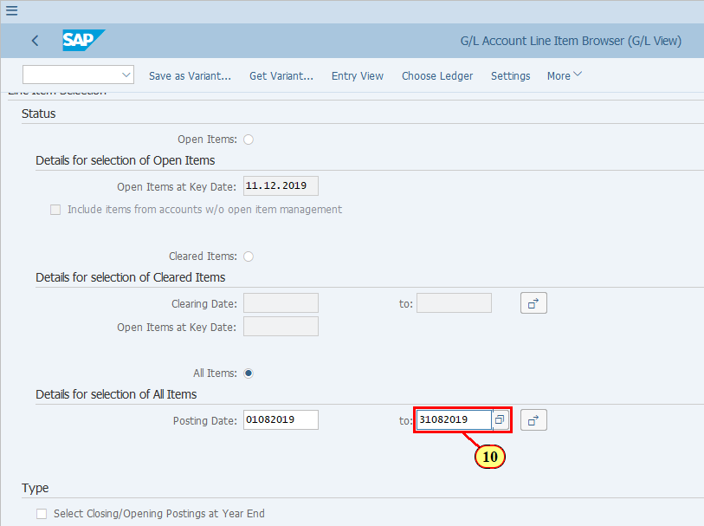
[11] Click Execute .  You can also press F8. | 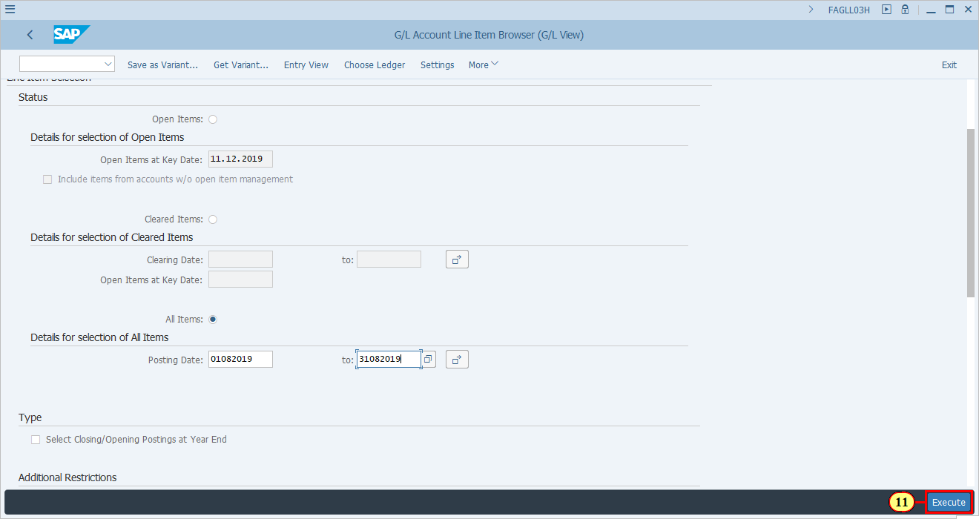
  Upon display of the items which have met our selection criteria, we can take a look at the details of a document.  [12] Click DocumentNo . | 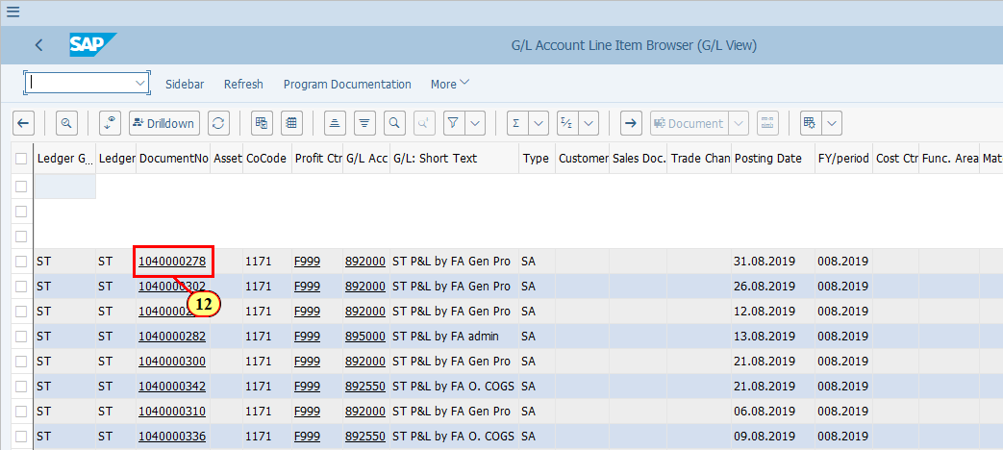
[13] Click Choose .  You can also press Enter. | 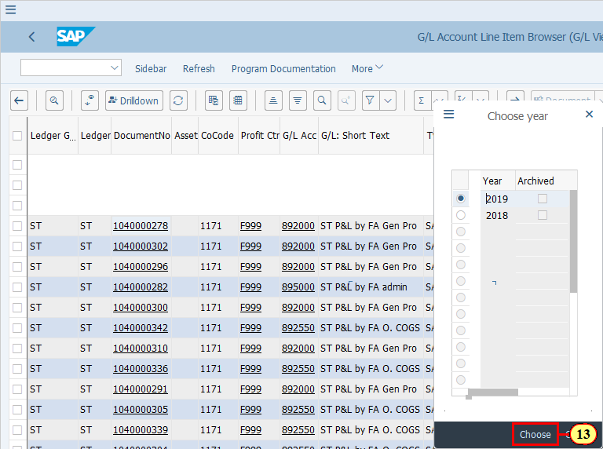
  This is the Functional Area Adjustment document.  You may validate the following key information, which is based on ZFGL01 execution (the variant used):  - Company Code  - Ledger  - Document Date - the date when you executed ZFGL01  - Debit/Credit G/L accounts used for posting (Postings are between a Functional Area Adjustment account representing a specific Functional Area such as 891000, 892000, etc. and a balancing account 899999.)  The following information is based on the original P&L document:  - Posting Date / Posting Period  - Reference (original document number)  - Currency  - Amounts  - Profit Center  You can use all the above fields to filter and search for any specific Functional Area Adjustment postings back on the FAGLL03/FAGLL03H report.  Click on when you are ready to continue.  [14] Click Display Document Header .  You can also press F5. | 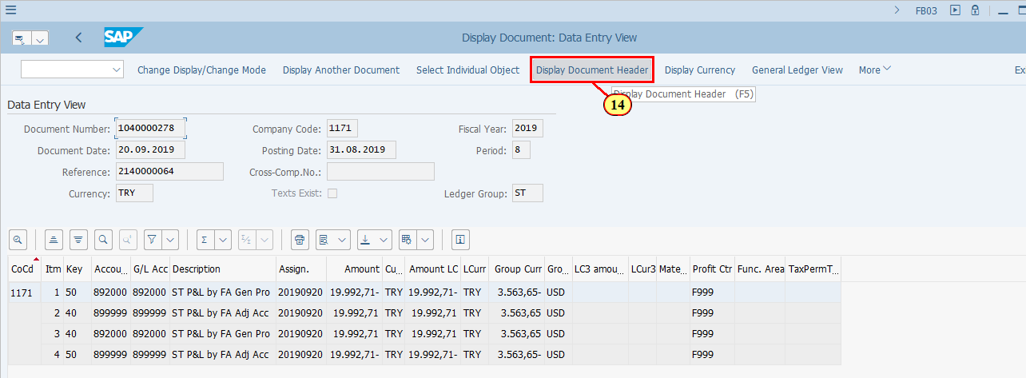
  Further in the Document Header you can find and validate the following information:  - Document type: It is SA in majority of the cases unless your ZFGL01 variant has specified the use of "External Document Type", which is the same as the document type of the original P&L posting.  - Doc.Header Text: It inherits the same Doc.Header Text of the original document.  - Reference: This is the document number of the original P&L posting(s) which was selected for Functional Area Adjustment in ZFGL01.  - Currency: Same as Document Currency of the original document  - TCode: Should be ZFGL01 for normal Functional Area Adjustment posting and FB08 if you have reversed any documents posted via ZFGL01  Again, you can use these fields to filter or search for your required line items in FAGLL03/FAGLL03H reports. | 